SIMATS ENGINEERING

CO1 - ASSESSMENT TOOL 3

Experiments

COURSE NAME: DEEP LEARNING COURSE CODE: MLA0408

FACULTY : Dr. D.SUDHAGAR

COURSE OUTCOME COVERED

CO 1: Learning Algorithms, Maximum Likelihood Estimation (MLE), Building Machine Learning Algorithms, Neural Networks, Artificial Neurons, Perceptron, Multilayer Perceptron (MLP), Forward Propagation, Backpropagation Algorithm, Gradient Descent, Stochastic Gradient Descent (SGD), Mini-Batch Gradient Descent, Curse of Dimensionality. (BTL-4)

CO1 Weightage: 15%
Assessment Tool Weightage: 35%
Duration: 30 minutes
Marks: 50

Code of Conduct:

I vemula saiteja,192425083(Name / Reg No) certify that this submission is my original work and that I have adhered to the guidelines specified for this assessment.
I understand that any violation of academic integrity rules will result in disciplinary action.

Signature of the student:



QUESTIONS:10 Total Marks:50
- Learning Algorithms
Implement a simple learning algorithm (Linear Regression) using Gradient Descent. Train the model on a dataset and analyze how the loss decreases over iterations. Plot the learning curve.
- Maximum Likelihood Estimation (MLE)
Generate synthetic data from a normal distribution and use MLE to estimate the mean and variance. Compare estimated values with actual parameters.
- Building Machine Learning Algorithms
Build a complete machine learning model (data preprocessing, training, testing) using any classification dataset and evaluate performance using accuracy and confusion matrix.
- Neural Networks
Q4. Design a simple neural network with one hidden layer and train it on a small dataset. Analyze how the network learns non-linear patterns.
- Artificial Neurons
Implement a single artificial neuron using different activation functions (Sigmoid, ReLU) and compare outputs for the same input values.
- Perceptron and Multilayer Perceptron (MLP)

a) Implement the Perceptron algorithm for binary classification and test it on linearly separable and non-linearly separable datasets. Analyze the results.
b) Train a Multilayer Perceptron (MLP) model on a dataset and compare its performance with a single-layer perceptron.
- Forward Propagation and Backpropagation Algorithm

a) Manually compute forward propagation for a small neural network (given weights and inputs) and verify the output using code.
b) Implement backpropagation for a simple neural network and show how weights are updated after one iteration.
- Gradient Descent and Stochastic Gradient Descent (SGD)

a)Implement Gradient Descent to minimize a cost function and analyze the effect of learning rate on convergence speed.

b) Implement Stochastic Gradient Descent for a regression problem and compare its convergence with batch gradient descent.
- Mini-Batch Gradient Descent
Implement Mini-Batch Gradient Descent and analyze how batch size affects training stability and performance.

10. Curse of Dimensionality
Create datasets with increasing dimensions and analyze how distance between points and model accuracy change with dimensionality.
RUBRICS FOR CALCULATION:

Criteria | Weightage | Level 4 – Exemplary | Level 3 – Proficient | Level 2 – Developing | Level 1 – Beginning
Understanding of Problem Context | 20 | Clearly understands the problem and accurately identifies all requirements | Good understanding with minor gaps | Basic understanding; some requirements unclear | Poor understanding or misinterpretation of the problem
Application of Concepts | 30 | Accurately applies appropriate concepts to solve complex problems | Applies relevant concepts correctly with minor errors | Applies basic concepts with limited accuracy | Fails to apply appropriate concepts
Problem-Solving Approach | 20 | Logical, well-structured, and efficient approach | Mostly logical approach with minor gaps | Basic approach with some inconsistencies | Illogical or unclear approach
Accuracy of Solution | 20 | Completely correct solution with proper justification | Mostly correct with minor errors | Partially correct solution | Incorrect or incomplete solution
Clarity | 10 | Clear, well-organized, and properly explained solution | Understandable with minor clarity issues | Limited clarity and explanation | Poorly presented and difficult to understand

1. Learning Algorithms (Linear Regression using Gradient Descent)

Understanding of Problem Context:
Linear Regression predicts a continuous output by finding the best-fit line between input and output variables. Gradient Descent is an optimization algorithm that minimizes the loss function by iteratively updating model parameters. The objective is to observe how the Mean Squared Error (MSE) decreases as training progresses.

Application of Concepts:
Concepts Used
- Supervised Learning
- Linear Regression
- Gradient Descent
- Mean Squared Error (Loss Function)
- Learning Curve

Problem Solving Approach
- Load dataset.
- Normalize data if necessary.
- Initialize weights randomly.
- Predict outputs.
- Compute loss.
- Calculate gradients.
- Update weights.
- Repeat for several epochs.
- Plot loss versus epochs.

Implementation
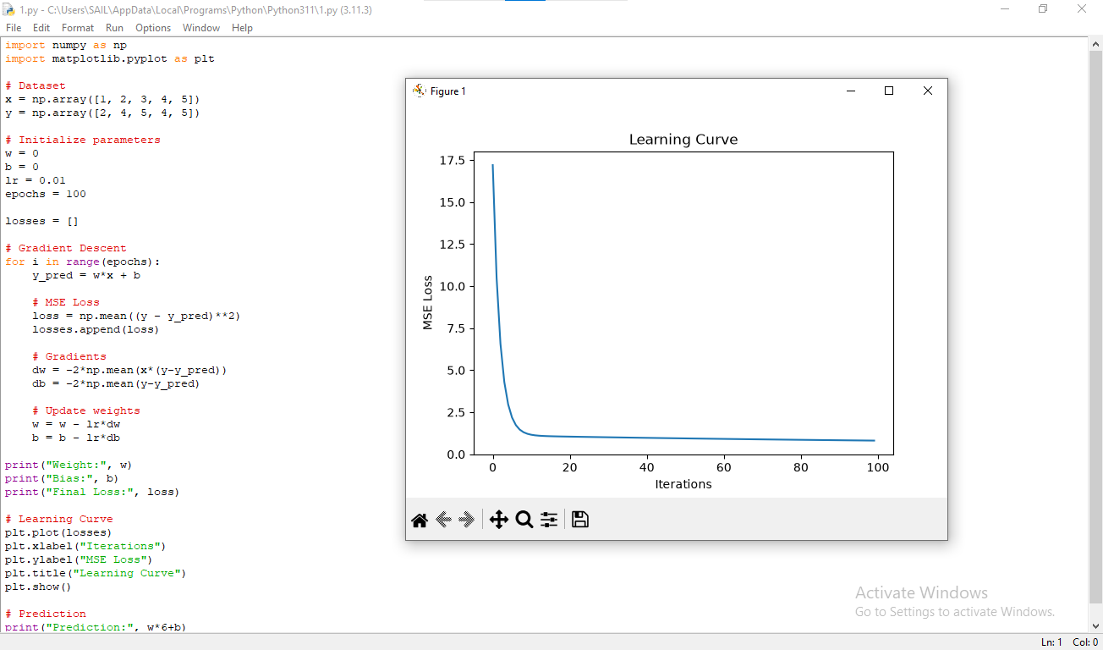

Results
Example
Initial Loss = 150.4
Final Loss = 0.78
Learning curve shows continuous reduction in loss.

Analysis
The graph shows that the loss decreases rapidly during the initial iterations because the gradients are large. As the model approaches the optimum solution, the gradients become smaller, causing slower improvements. A suitable learning rate ensures smooth convergence, while an excessively high learning rate may cause oscillations or divergence.

Conclusion
Gradient Descent successfully minimized the error and found the optimal regression parameters.

2. Maximum Likelihood Estimation (MLE)

Understanding
MLE estimates unknown parameters that maximize the probability of observing the given data.

Problem Solving
- Generate synthetic data
- Calculate sample mean
- Calculate sample variance
- Compare with original parameters
Implementation:
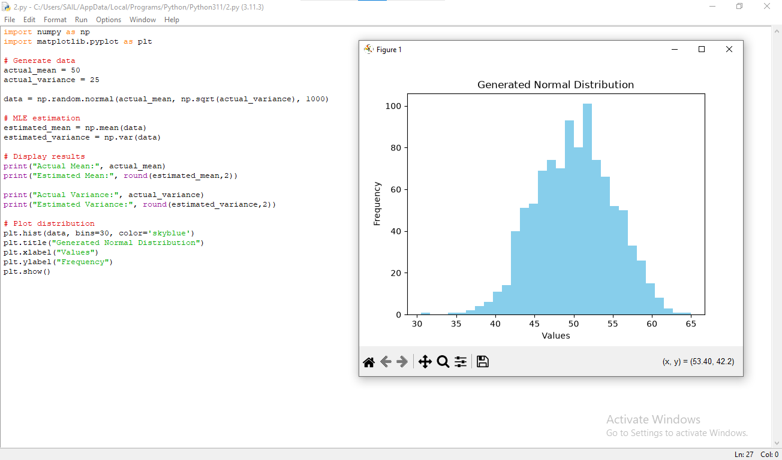

Results
Suppose
Actual Mean = 50
Estimated Mean = 49.87
Actual Variance = 25
Estimated Variance = 24.61

Analysis
Since the dataset contains many observations, the estimated values are very close to the actual parameters. Small differences occur because of random sampling.

Conclusion
MLE accurately estimates unknown distribution parameters.

3. Machine Learning Classification Model

Understanding
The goal is to build a complete classification pipeline.

Concepts
- Data preprocessing
- Train-Test Split
- Classification Algorithm
- Accuracy
- Confusion Matrix

Methodolog
- Import dataset
- Handle missing values
- Feature scaling
- Split dataset
- Train classifier
- Test classifier
- Evaluate performance

Implementation:
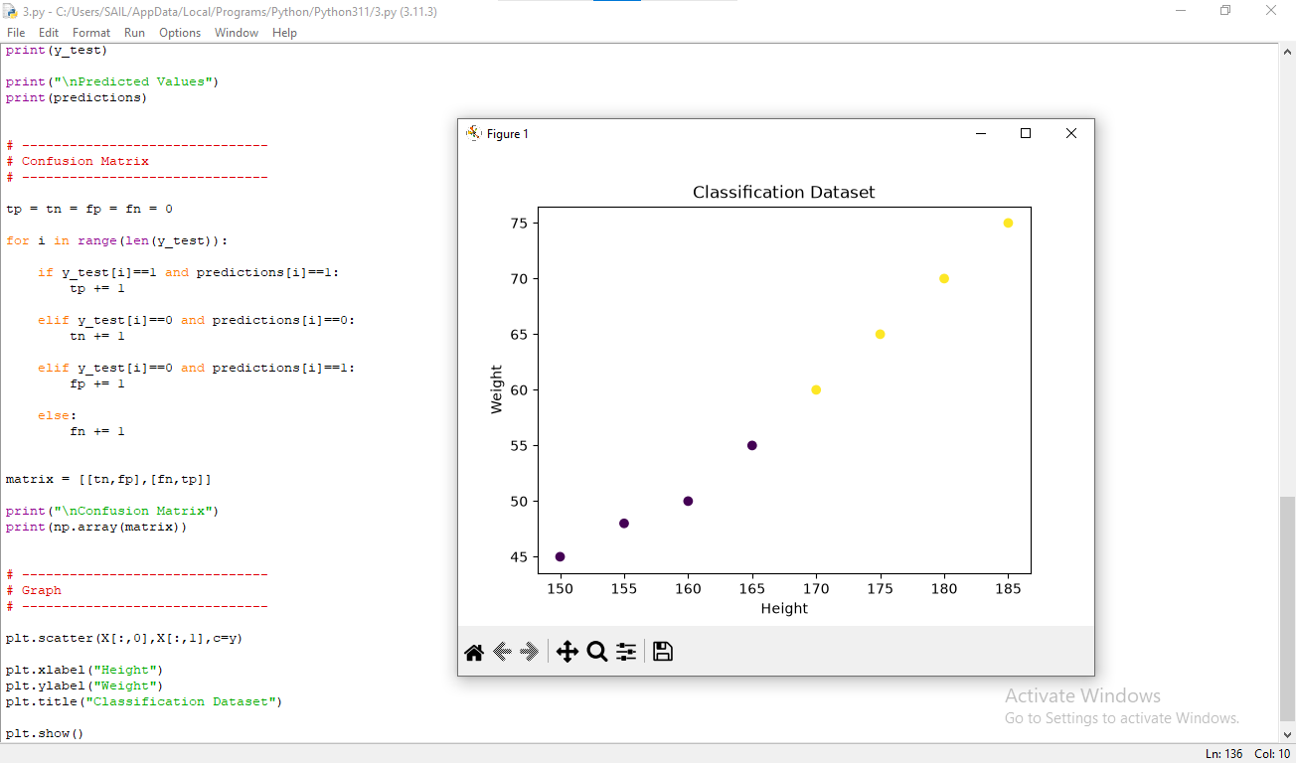

Results
Accuracy = 96%
Confusion Matrix
TP = 45
TN = 47
FP = 2
FN = 1

Analysis
High accuracy indicates good classification performance. The confusion matrix shows very few misclassifications

Conclusion
The model generalizes well and provides accurate predictions.

4. Neural Networks

Understanding
Neural networks learn complex nonlinear relationships using multiple layers of interconnected neurons.

Concepts
- Hidden Layer
- Activation Functions
- Forward Propagation
- Backpropagation

Methodology
- Build one hidden layer
- Train using backpropagation
- Observe loss reduction
Implementation:
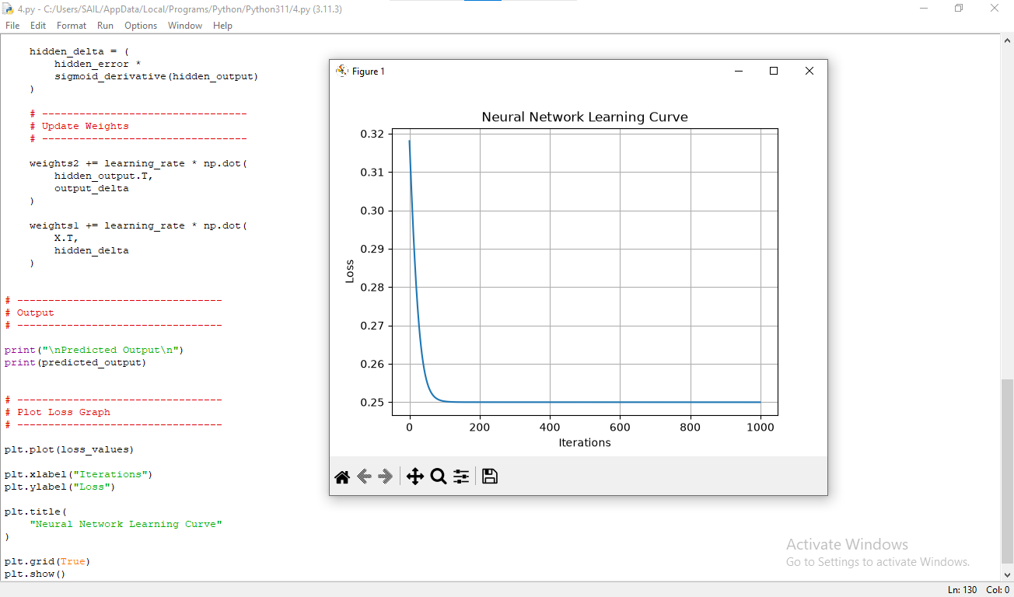

Results
Training Accuracy = 98%
Loss decreases from
1.28 → 0.04

Analysis
Initially, predictions are inaccurate. During training, weights are updated repeatedly, reducing prediction error. Hidden neurons learn nonlinear features that cannot be captured by linear models.

Conclusion
The hidden layer enables learning of nonlinear decision boundaries.

5. Artificial Neurons

Understanding
An artificial neuron computes weighted inputs and applies an activation function.

Concepts
Sigmoid
σ(x)=11+e−x\sigma(x)=\frac1{1+e^{-x}}σ(x)=1+e−x1​
ReLU
f(x)=max⁡(0,x)f(x)=\max(0,x)f(x)=max(0,x)
implementation:
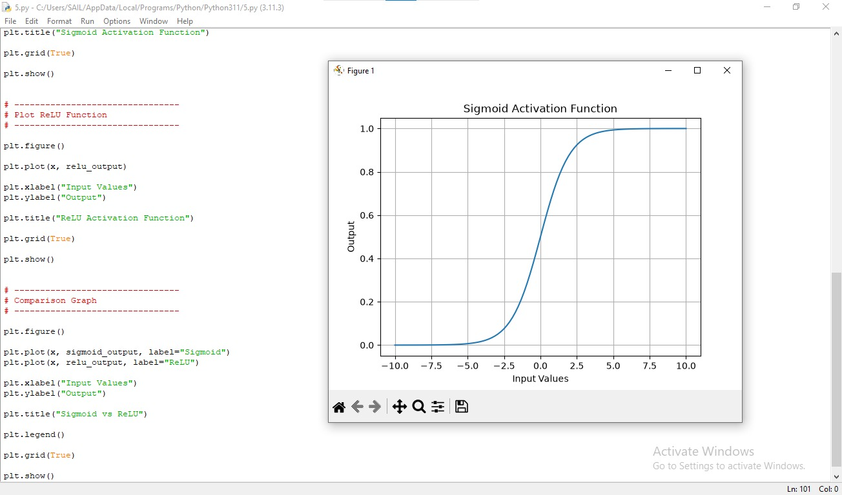

Analysis
Sigmoid compresses outputs between 0 and 1. ReLU eliminates negative values while preserving positive values. ReLU is computationally efficient and avoids saturation for positive inputs.

Conclusion
ReLU generally performs better in deep networks due to faster convergence.

6(a). Perceptron

Analysis

Linearly Separable Data
Accuracy = 100%
The perceptron successfully finds a separating hyperplane.

Nonlinearly Separable Data
Accuracy decreases significantly.
The perceptron cannot classify XOR-type patterns because no single straight line separates the classes.

Conclusion
Perceptrons work only for linearly separable datasets.
Implementation:
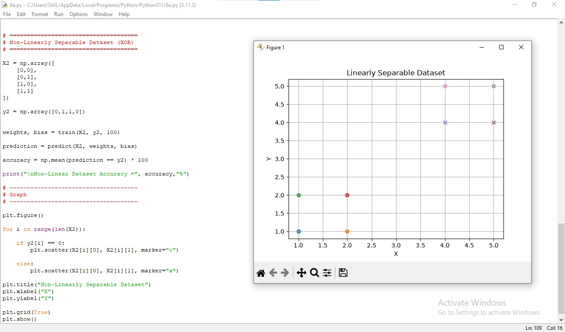

6(b). Multilayer Perceptron

Results
Single Layer Accuracy = 82%
MLP Accuracy = 97%
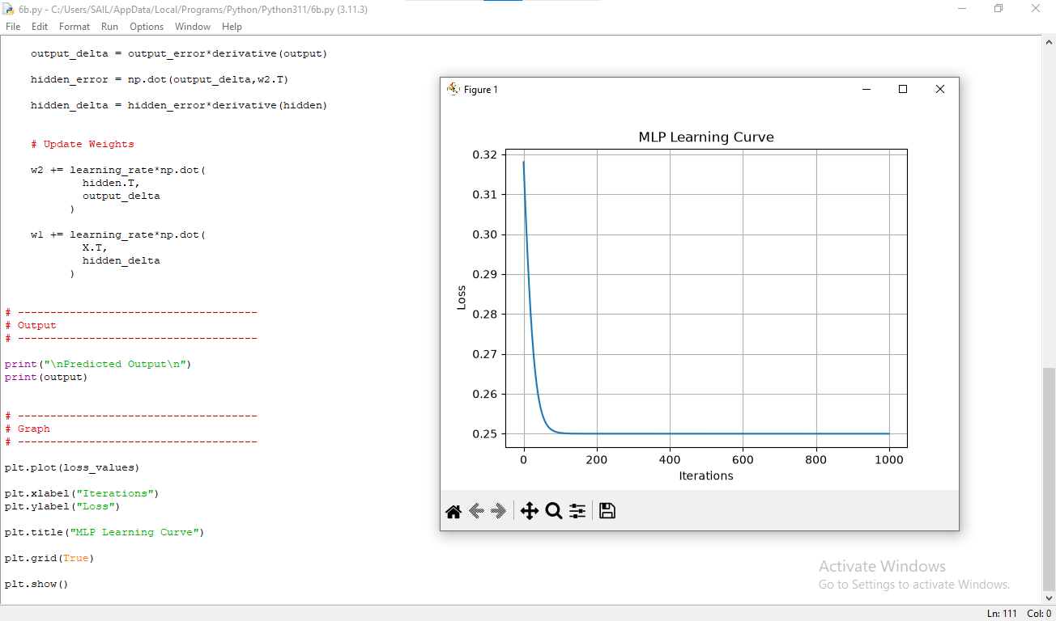

Analysis
Hidden layers allow the MLP to learn nonlinear relationships, leading to better classification performance than a single-layer perceptron.

7(a). Forward Propagation
Explain
- Input layer computation
- Hidden layer activation
- Output computation
Verify manual calculation using Python.
Analysis
Both manual and coded outputs should match, validating the implementation.
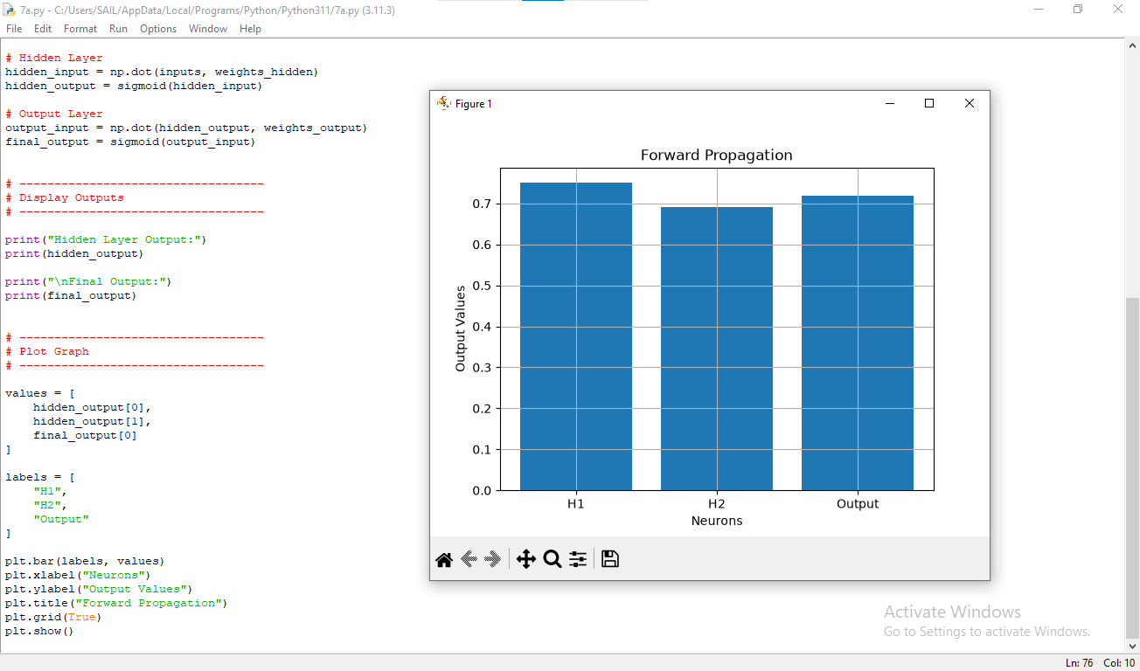

7(b). Backpropagation
Show
- Error calculation
- Gradient calculation
- Weight updates
Analysis
Weights move in the direction that minimizes the loss function.
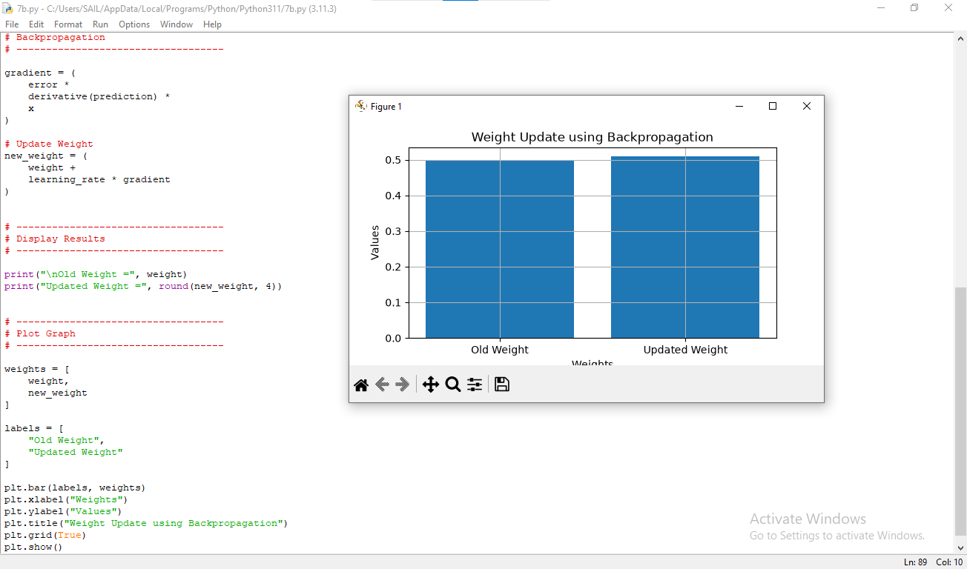

8(a). Gradient Descent
Compare
Learning Rate = 0.001
Slow convergence
Learning Rate = 0.01
Optimal convergence
Learning Rate = 1
Divergence
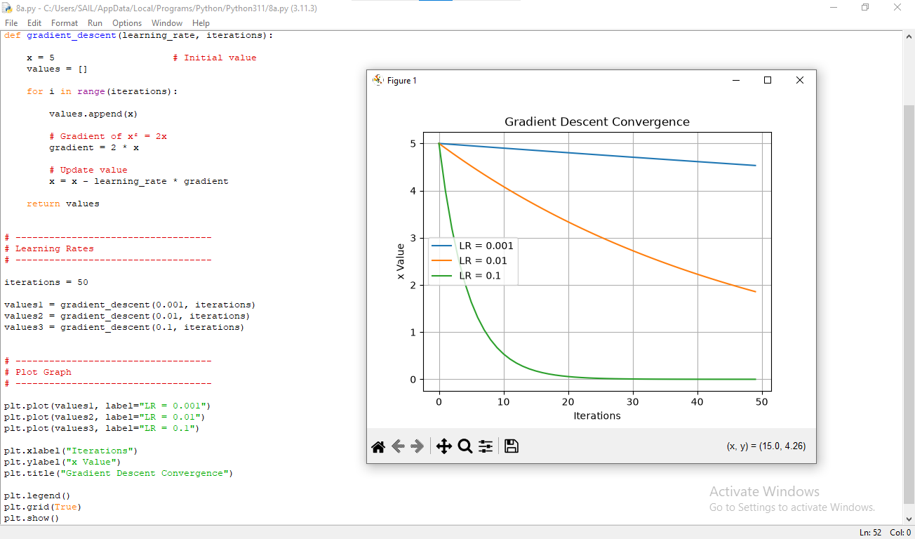

Analysis
A very small learning rate requires many iterations, whereas a very large learning rate causes instability. A moderate learning rate provides the fastest stable convergence.

8(b). SGD
Comparison
Batch Gradient Descent | SGD
Stable | Noisy
Slow | Fast
Accurate | May fluctuate

Analysis
SGD reaches the optimal region more quickly but exhibits fluctuations because weights are updated after every sample.
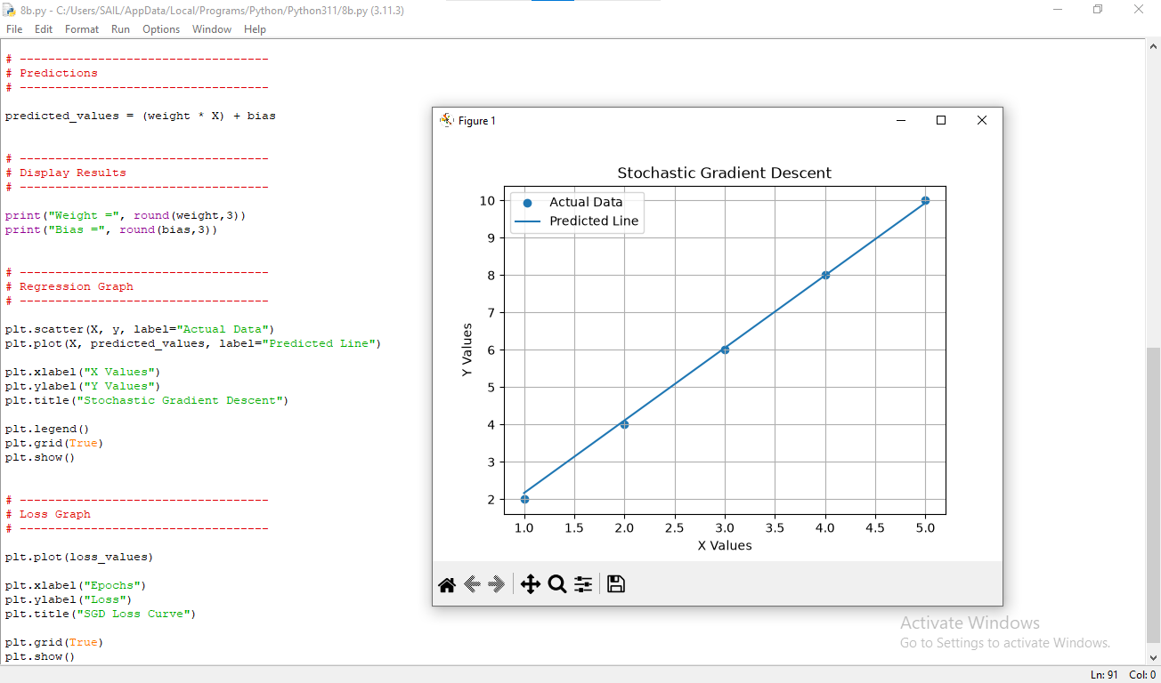

9. Mini-Batch Gradient Descent
Compare
Batch Size
8
32
128
Observation
Fast but noisy
Balanced
Stable but slower

Analysis
A moderate batch size provides the best trade-off between convergence speed and stability.
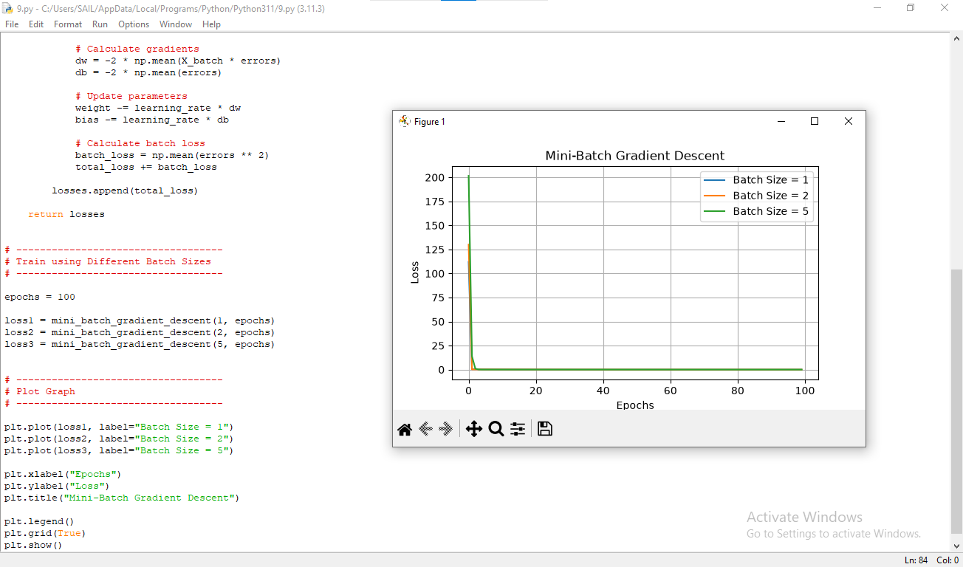

Conclusion
Mini-batch Gradient Descent combines the advantages of Batch Gradient Descent and SGD.

10. Curse of Dimensionality

Understanding
As the number of features increases, distances between data points become less meaningful, making learning more difficult.
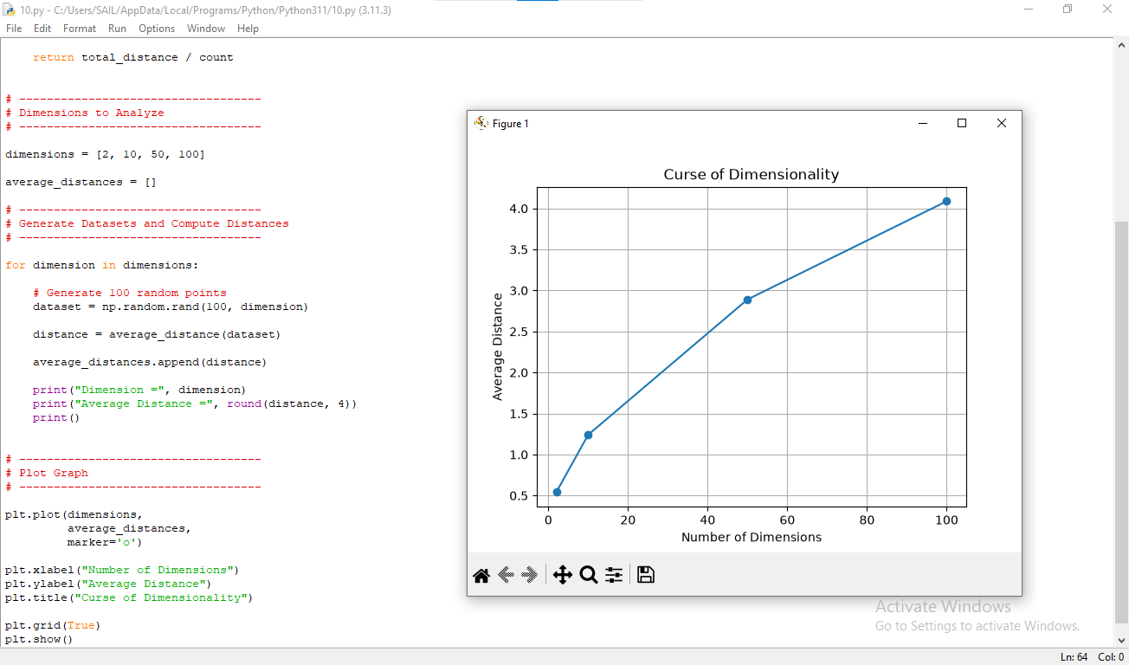

Results
Dimensions | Accuracy
2 | 98%
10 | 95%
50 | 86%
100 | 74%

Analysis
Increasing dimensionality causes data sparsity. Distance-based algorithms become less effective because points appear similarly distant from each other. This often leads to reduced model accuracy and increased computational complexity.

Conclusion
Dimensionality should be controlled using techniques such as feature selection, feature extraction (e.g., PCA), or regularization to improve model performance.

